دیاگرام ER و relational schema برای یک دیتا بصورت زیر است.

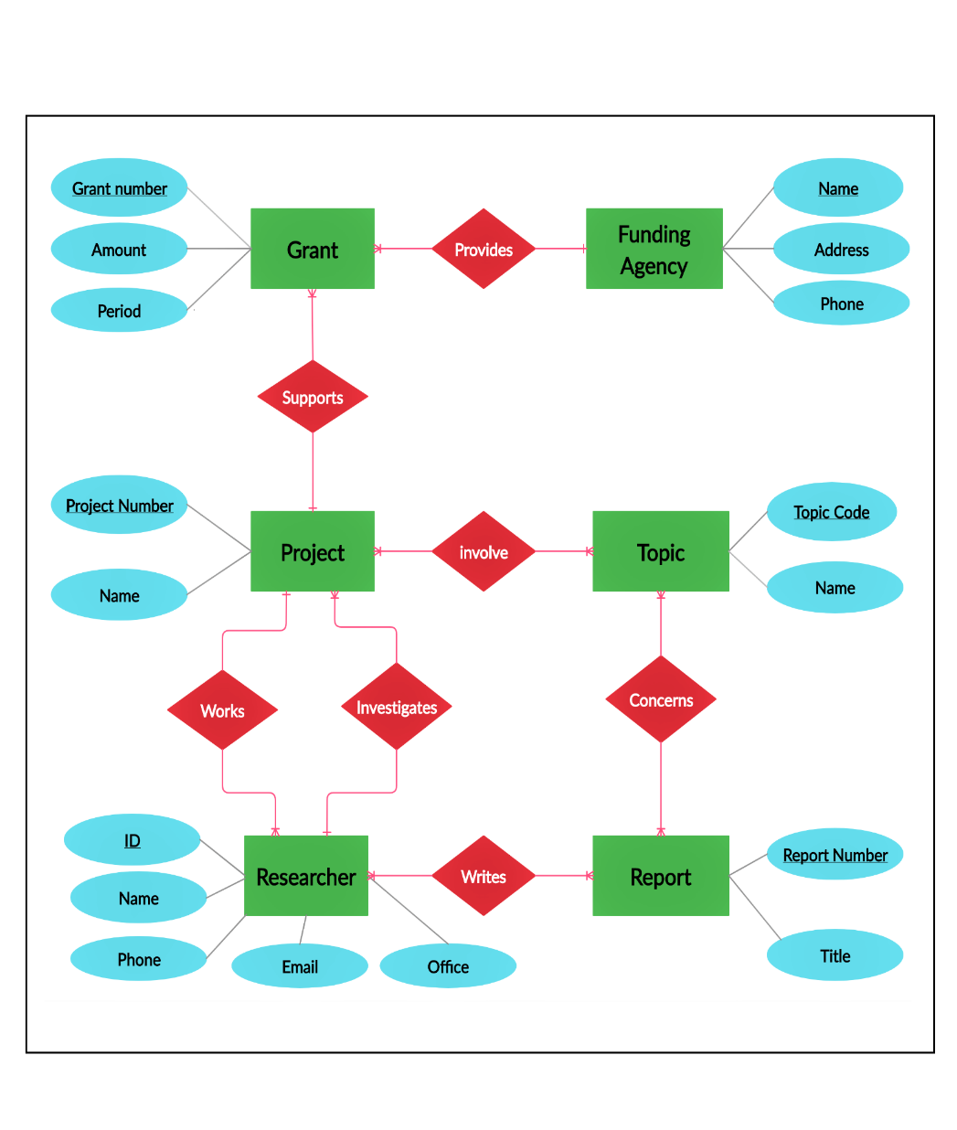

Funding Agent(Name, Address, Phone)

Grant (Grant Number, Amount, Period)

Project (Project Number, Name)

Topic (Topic Code, Title)

Researcher (ID, Email, Name, Phone, Office)

Report (Report Number, Title)

Provides ( Grant Number, Name)

Supports (Grant Number, Project Number)

Involve (Project Number, Topic Code)

Works (ID, Project Number)

Writes (ID, Report Number)

Investigates (Project Number, ID)

**سوالات خواسته شده: (فایل A2 ضمیمه شده است.)**

1) Implement your design by using PostgreSQL. Write an SQL script to create relations and write a script to load the data in A2.data into the database.

2)Write a script in PL/pgSQL for each of the following.

1. Write a function to get the numbers, titles and topic codes of reports that a given researcher has authored. The function takes a researcher ID as its parameter.

2. For each researcher, if he/she serves as a PI, print researcher ID, name, and the total amount of funding, otherwise, print ID, name and “Not applicable”.

3. Write a function for adding a project and a grant for it into the database. The function has the following parameters: project number, project name, topic code, ID number of the PI, grant number, amount, period, and funding agency.